***Case Study 1***

1. Requirement Definition (RD)

-Admin can register the staff through the system by entering individual’s username and password.

-Admin can access the customer service panel.

-Admin can send the customer service receipt to the customers.

-The staff can log in with their name and password to access the system.

-The staff can proceed to new product sales and services accordingly.

-The staff can send a copy of sales receipt to customers.

-The staff can also update the customer service records on demand.

2. Data Requirements

-Staff details (username & password)

-Log in information

-New sales and services demands

-Receipts (Sales & Services)

3. Functional Requirements

-The system supports customers purchased receipt.

-System can search the product from the stock according to customers demand.

- System can add stock.

- System can update stock.

- System can delete stock.

- System can show the stock report.

- System can show the sales report.

- System can register new staff.

- System can add customer service.

- System can update customer service.

- System can view all the service records according to product specific ID.

- System can update password (Admin & Staff).

4. Non-functional Requirements

-The system can save stock into the database safely.(ACID properties)

- The system can support all the PC (Personal Computer).

-The system can create a backup database file after every transaction (sales, stock, service, update of authentication details).

- Stock should be added after end of sales per day.

- For security issues only admin can change the password on behalf of staffs.

- Staffs can only access this system for sales, service and checking reports.

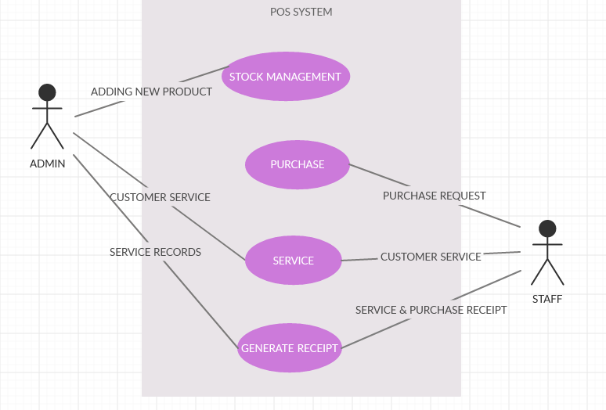

Fig . Use Case Diagram for POS System